BT 6270 : Computational Neuroscience

Assignment #2

--------------------------------------------------------------------------------------------------------------

**General Instructions:**

* The goal of this assignment is simulating and Understanding FitzHugh-Nagumo neuron model taught in the class.
* This is an individual assignment.
* You may use MATLAB for your implementation.
* You have to turn in the well commented code along with a detailed report of the study.
* Your report should contain answers for all of the questions/cases asked below.
* Look at the end of the assignment for submission instructions.
* **Submission deadline: 30th September, 2018 (23:59).**

____________________________________________________________________________________

_____________________________________________________________________________________

**Simulate the two variable FitzHugh-Nagumo neuron model using the following equations :**

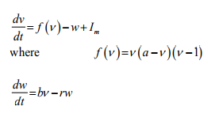

where a=0.5; choose b, r values as discussed in the class (small positive values, say 0.1)

**Use single forward Euler Integration**

dv/dt = Δv/ Δt

Δv(t) = v(t+1) - v(t) = [fv(t) - w(t) + Iext(t)]* Δt given v(0) --> v(Δt ) --> v(2* Δt ) -->....

**Case 1:** Iext = 0

(a) Draw a Phase Plot superimposed (use hold on command in MATLAB)

(b) Plot V(t) vs t and W(t) vs t and also show the trajectory on the phase plane for the both cases

(i) V(0) < a and ω (0)= 0

(ii) V(0) > a and ω (0)= 0

**Case 2:** Choose some current valueI1 < Iext < I2 where it exhibit oscillations. Find the values of I1 and I2.

(a) Draw a Phase Plot for some sample value of Iext

(b) Show that the fixed point is unstable i.e., for a small perturbation there is a no return to the fixed point (show the trajectory on the phase plane) – also show limit cycle on the phase plane

(c) Plot V(t) vs t and W(t) vs t

**Case 3:** Choose some Iext > I2

(a) Draw a Phase Plot for some sample value of Iext

(b) Show that the fixed point is stable i.e., for a small perturbation there is a return to the fixed point (show the trajectory on the phase plane)

(c) Plot V(t) vs t and W(t) vs t

**Case 4:** Fine suitable values of Iext and (b/r) such that the graph looks as phase plot shown as below.

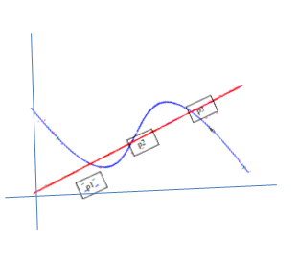

(a) Redraw the Phase plot

(b) Show suitability of P1, P2, P3

(c) Plot V(t) vs t and W(t) vs t

**Do not share your assignments with each other. Discussions are permitted but the code and the final report must be an individual effort. Please feel free to mail the group any doubts.**

**Submission Instructions**

Enclose all your programs, plots and report in a single zip folder

Submit a compressed  zip or tar file named as <ROLLNO>_A2.zip to any one of the following address. **Please note do not drop your assignment on to the group.**

[*anila.gundavarapu@gmail.com*](mailto:anila.gundavarapu@gmail.com) *or* [*bhadra.edu@gmail.com*](mailto:bhadra.edu@gmail.com)

------ o -------